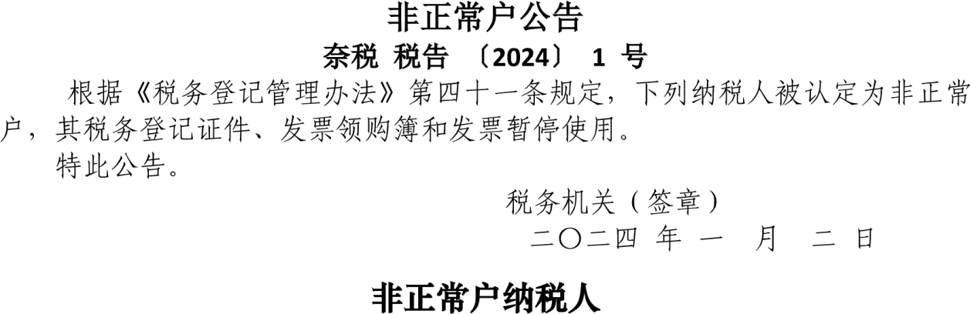

|  |  |  |  |  |  |  |  |  |
| --- | --- | --- | --- | --- | --- | --- | --- | --- |
|  |  |  |  |  |  |  |  |  |
|  |  |  |  |  | 152326********0014 |  |  |  |
|  |  |  |  |  | 152326********0010 |  |  |  |